Comp 1536 Website Development Project

Milestone #4: Deployed Javascript-Enabled Site -Validated, Tested

Raly Tan, Carlo Mendoza, Toni He, Kevin Chow

Set B

Table of Contents

Milestone #4 Deployed Javascript-Enabled Site – Validated, Tested 3

Appendix A: Milestone #1 Project Proposal 9

Appendix B: Milestone #2 Site Map and Page Design 12

Appendix C: Milestone #3 Skeleton Site with Layout, Tables and Forms 38

# Milestone #4 Deployed Javascript-Enabled Site – Validated, Tested

**MILESTONE #4**

**DEPLOYED JAVASCRIPT-**

**ENABLED SITE-**

**VALIDATED, TESTED**

**URL with current completed website:** http://students.bcitdev.com/A01005764/G26/index.html

**COMPLETED ITEMS:**

- Made many changes to visual design of website, including transition features to header and image backgrounds

- Created function site pages for users to post messages, log-in, and view posts on website

-waiting on Milestone 5 to add PHP functionality to posts and forum page

- Implemented Javascript validation requirements to all site forms and posting features

-created validation requirement tables to identify the features necessary for form validation

-tested these form validation features internally and externally to check for bugs and exceptional cases

- Added Javascript third party widget on index page, that provides visual appeal to site and fits theme of company

- Coded a small Javascript feature that enables smooth-scrolling on our back-to-top button on all pages

-Tested site with Javascript disabled, to ensure that features did not disrupt the form validation process

-Continually tested the site during the design process, retaining the structure of our pages, and ensuring that our changes and features were implemented correctly.

-Created wireframe layouts for additional pages we created for this Milestone

-Verified HTML and CSS files were validated using the W3C validators

**EXTRA WORK COMPLETED:**

For this Milestone, a placeholder video was added to the index page, that will be replaced by our own content for the final Milestone. The Javascript widget we implemented is a cool space background for our company model and features moving constellations that follow the mouse as it travels across the background. We felt that this feature would fit the space or rocket theme of the website and we are looking at additional ways to make this theme consistent throughout the site. Carlo made sure to include tab index functionality to all our form pages to make our site more user friendly. Also, we began to add visual content to our site, including many local pictures of Vancouver that Toni had taken. Finally, we added a responsive hover feature in our header that creates a transition effect and dropdown menus to improve navigation through our site.

**FORM VALIDATION REQUIREMENTS AND TESTING TABLES:**

|  |  |  |
| --- | --- | --- |
| FORM on page: Contact Us |  |  |
| Field ID | **Data Format or RegExp** | **Explanation** |
| firstname | Test box containing a string of the user’s first name. Must not be blank. | First name can be written however users like but cannot be blank as we would want to know who to address our responses to. |
| lastname | Test box containing a string of the user’s last name. Must not be blank. | Last name can be written however users like but cannot be blank as we would want to know who to address our responses to. |
| email | Test box containing a string of the user’s email.  RegExp: /\S+@\S+\.\S+/ | Email needs to have a string followed by an @ symbol followed by another string and a . ending in another string. The format should look similar to [string@string.string](mailto:string@string.string) If the format is incorrect, the field is reset to blank so that the user has to type in another string. |
| message | Text area containing the user’s message. No restrictions. | We decided not to validate this field so that users can say as much, or as little as they want. Users will be unlikely to try to abuse this as they would have to fill out the contact information fields every time in order for the data to submit. |

|  |  |  |
| --- | --- | --- |
| FORM on page: Community |  |  |
| Field ID | **Data Format or RegExp** | **Explanation** |
| loginname | Text box for registered users to enter their username. Must not be blank. | No validation required other than the “required” attribute for the input element to keep the field from being submitted while blank. |
| loginpass | Text box for registered users to enter their password. Must not be blank. | No validation required other than the “required” attribute for the input element to keep the field from being submitted while blank. |
| firstname | Text box for unregistered users to enter their first name. Must not be blank. | First name can be written however users like but cannot be blank as we would want to know who is signing up to use our forum. This can also help personalize our messages to users. |
| lastname | Text box for unregistered users to enter their last name. Must not be blank. | Last name can be written however users like but cannot be blank as we would want to know who is signing up to use our forum. This can also help personalize our messages to users. |
| email | Text box for unregistered users to enter their email.  RegExp: /\S+@\S+\.\S+/ | Last name can be written however users like but cannot be blank as we would want to know who is signing up to use our forum. This can also help personalize our messages to users. |
| username | Text box for unregistered users to enter their desired username. Must not be blank. | Email needs to have a string followed by an @ symbol followed by another string and a ‘.’ and ending in another string. The format should look similar to [string@string.string](mailto:string@string.string) If the format is incorrect, the field is reset to blank so that the user has to type in another string. Email is necessary for users to submit so that we can contact them |
| password_0 | Text box for unregistered users to enter their desired password. Must not be blank. | All accounts should have a password associated with them. We have not set limits on length or requirements on what passwords should contain at this time so that users have more flexibility when signing up. |
| Password_1 | Text box to confirm users’ password. This input must match the input in the field above. | User’s need to confirm their passwords to ensure that they are error-free and more likely to remember them when they log back into our site. |

|  |  |  |
| --- | --- | --- |
| TEST DOCUMENTATION for FORM on page: Contact Us |  |  |
| Field ID | **Problem** | **Improvements made** |
| firstname | Users could leave the field blank and submit the information. | Implemented JavaScript validation to post a message alerting the user to not leave the field blank and will not submit until the field is filled. |
| lastname | Users could leave the field blank and submit the information to the server. | Implemented JavaScript validation to post a message alerting the user to not leave the field blank and will not submit until the field is filled. |
| email | Users can input anything into the email field even if it does not follow proper email format. | Implemented JavaScript validation with RegExp to alert the user if their input does not meet proper email format (contains @ and .) |
| message | No problems working as intended | No problems working as intended |
| FORM LEVEL TESTING |  |  |
| Form flow | **Problem** | **Improvements made** |
| Contact Us message form | No problems, working as intended | No problems, users are able to submit their information to the server. |

|  |  |  |
| --- | --- | --- |
| TEST DOCUMENTATION for FORM on page: Contact Us |  |  |
| Field ID | **Problem** | **Improvements made** |
| loginname | Users could leave the field blank and submit the information. | Implemented JavaScript validation to post a message alerting the user to not leave the field blank and will not submit until the field is filled. |
| loginpass | Users could leave the field blank and submit the information to the server. | Implemented JavaScript validation to post a message alerting the user to not leave the field blank and will not submit until the field is filled. |
| firstname | Users could leave the field blank and submit the information. | Implemented JavaScript validation to post a message alerting the user to not leave the field blank and will not submit until the field is filled. |
| firstname | No problems, working as intended | No problems, working as intended |
| lastname | No problems, working as intended | No problems, working as intended |
| email | Users can input anything into the email field even if it does not follow proper email format. | Implemented JavaScript validation with RegExp to alert the user if their input does not meet proper email format (contains @ and .) |
| username | No problems, working as intended | No problems, working as intended |
| password_0 | No problems, working as intended | No problems, working as intended |
| password_1 | Users could enter different passwords for password_0 and password_1 | Implemented javascript to append password_1 to password_0 and reflected as valid only if they both match. |
| FORM LEVEL TESTING |  |  |
| Form flow | **Problem** | **Improvements made** |
| Sign in Form | No problems, working as intended | No problems, users are able to submit their information to the server. |
| Register Form | No problems, working as intended | No problems, users are able to submit their information to the server. |

**KEY ISSUES ENCOUNTERED WITH THIS MILESTONE:**

The primary challenge our group encountered this Milestone was making all of the form validation requirements work with Javascript. It was definitely a learning process for us but we are at this point happy with the outcome. Feature that our group is interested in doing for the last Milestone is password strength validation when users sign up on the site and a log-in display for users when they are logged on and browsing on the site.

Some additional challenges arose when we added visual features to the site, including the new transition header. These features sometimes broke the layout of the site and we had to figure out ways to reformat the structure.

# Appendix A: Milestone #1 Project Proposal

**APPENDIX A:**

**MILESTONE #1**

**PROJECT PROPOSAL**

**YOUR WEBSITE IS YOUR ONLINE PRESENCE AND REPUTATION.**

INTRODUCTION

Our project team is going to create a site for a web design studio that showcases our skills in graphical design and web development. It ideally would cater to small, local businesses without an existing online presence. In the current age of business and advertising, it is critical to be able to reach out to the public through the Web to promote what your company or business has to offer. This project would also be useful in showing future employers what our capabilities are as web developers and the type of product we can create as part of a small team.

PURPOSE

The purpose of the site is showcase and highlight the skills of the web design studio. The site should be the primary means to show potential clients what kind of special features or graphical elements the studio can add to a website. The website should allow the studio to network with local business owners and to fulfill the need for local businesses to have an online presence.

GOALS

Our main goal is to create a professional looking website that can show off our skills as web developers and give our customers a feel for the types of ideas that we have which we can apply to their websites. We want to create a site that is not only professional, but also inspirational for local business owners. Customers should be able to look at the site and think to themselves that they want to fill out our contact form and get in touch with us. Our site should be user-friendly and accessible, with our services clearly showcased.

CONTENT

Our website will not only include informative text sections but also logos, multimedia visuals, and modern HTML design features.

We will include a list of services or service models that we can offer customers as well as a blog section to catalogue the work we have done.  This will give customers the opportunity to have some insight in the development process and demonstrate our ability to integrate features like catalogues and lists.

We would like to implement a question forum to show customers or guests that no question is too small or big to ask, and that we are invested in their satisfaction. Implementing a membership signup will also be an integral part to how our clients communicate with us and view progress on their website’s design. This question forum will include a form log-in page and a separate forum page where customers can make comments. This will allow the company to communicate directly through an informal system with customers and provide feedback.

STRATEGY

Our target audience is local small businesses and start-up companies within the Lower Mainland.  We believe that these types of companies will be more drawn to our type of business as we be a lower-cost solution in comparison to our competition. The target demographic for our services would be adults in their 20s-30s who would be similar to us in their age and experience. This demographic would be easier for us to connect with and establish relationships with.

One of the biggest success factors for the site is having a professional looking website with high site traffic. We would want potential clients to be able to easily find and navigate our site in order to see what we could provide them.

WORKFLOW

Our team will have meetings during breaks to discuss ideas and work on milestones; in addition to working on the actual web page content.  Our schedules are very easy to work around because all four of us are in the same class set.  We will also coordinate and communicate online through group chats on instant messaging apps as well as through Google Docs.  Because of the convenience of our schedules and the resources available for us to communicate even outside of school, we will be able to meet all deadlines.

COMPETITION

Two similar web development studios that are also based in the Lower Mainland include Drive Digital and Wittycookie Studio.

<http://www.wittycookie.ca/portfolio-seo.html>

<https://drivedigital.ca/>

We thought Drive Digital had a professional layout and format for their pages; but there were some pages that we thought had too much empty space and required too much scrolling between sections of information. Their inclusion of a blog that keeps visitors updated on their projects and achievements is also a fantastic social media feature.

WITTYCOOKIE had a very unique and appealing style for their website which incorporated animations and doodles. What we found lacking was their navigation bar which required movement to become more visible, on certain pages the categories of the navigation bar was indiscernible against the background.

With this information in mind, we will try to strike a balance between style and accessibility that can match the appeal of the above sites while avoiding the same formatting shortcomings.

# Appendix B: Milestone #2 Site Map and Page Design

**APPENDIX B:**

**MILESTONE #2**

**SITE MAP AND PAGE DESIGN**

Site Map

We chose to create our website in hierarchical format, following a standard, well tested design. We kept in mind the “3-click” rule, in order to make our website easy to navigate and find desired information. Using other web development sites as a template, we created a site structure that focused on three primary aspects, the content we can create and show to our clients, information on the team for our users to have a more personalized experience, and a showcase of services with the development features we have learned.

Our website will use a fluid, single-column layout. This would make it easier to translate to mobile devices so that we may not have to use an extra stylesheet for them. Although three-column layout works well for most websites, ours will be built in such a way that there wouldn’t be a need for a sidebar and putting the nav bar into the header would open up space for us to use more graphical content. Being able to show off more graphics and showing good use of open space will be better for our site so that we can show customers more of our graphic-usage skills. Also, since we are targeting smaller businesses, they may not have as much content for each of their sites. Being able to show that we can work with less content and make it seem like more would be an asset for out business.

The colour theme we want to use incorporates cold tones into the design. We wanted to showcase professionalism in our services and to be taken seriously. We want our design to be appropriately contrasted, simplistic and easy to read, hence we've decided on a white background with black text and blue accent on the logo to hold the theme together.

<https://coolors.co/000000-111111-3268e5-183242-ffffff>

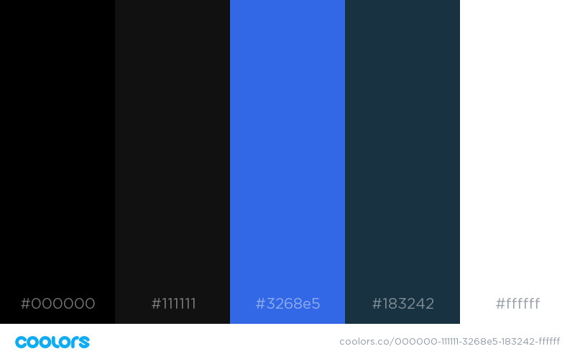

Home Page Layout

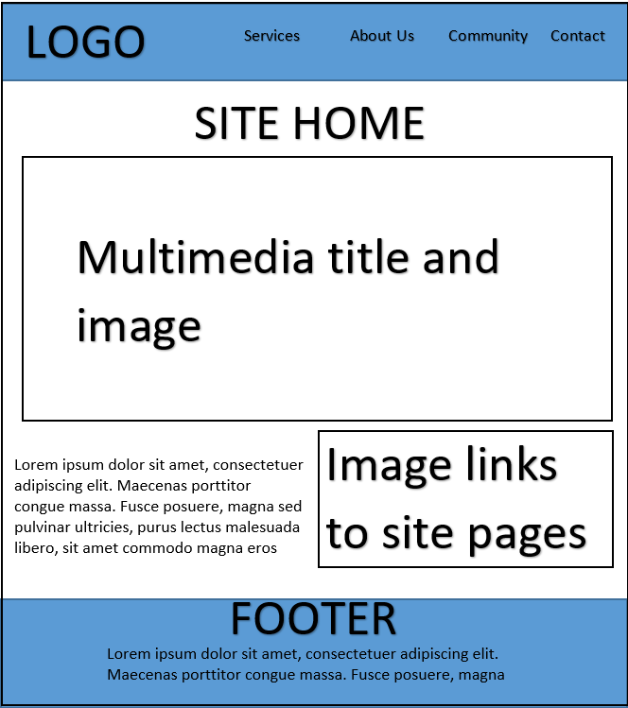

Home Page Print Layout

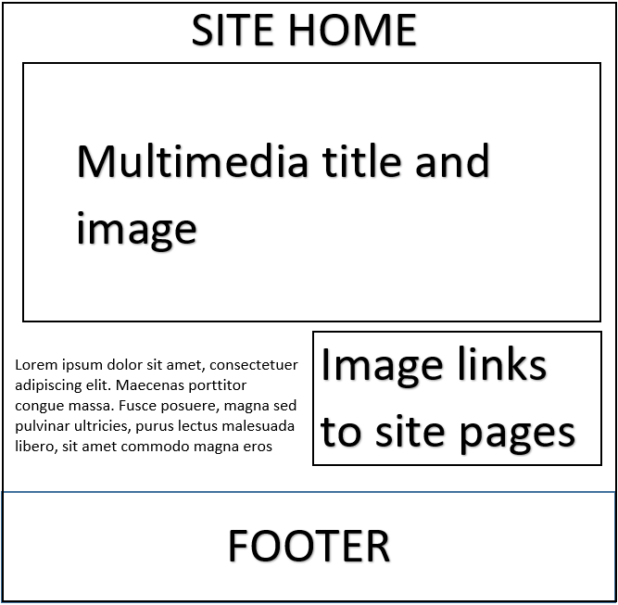

There will be a fixed position nav bar that scrolls along with the user that links to the separate main sections of our page. The homepage will feature a signature quote or phrase followed by a description of how we can help people market and improve their online presence. This is an eye-

catching design that will prompt the viewers to continue scrolling down. Farther down will also showcase many interact-able images that will link to the related category page.

**Services Page Layout**

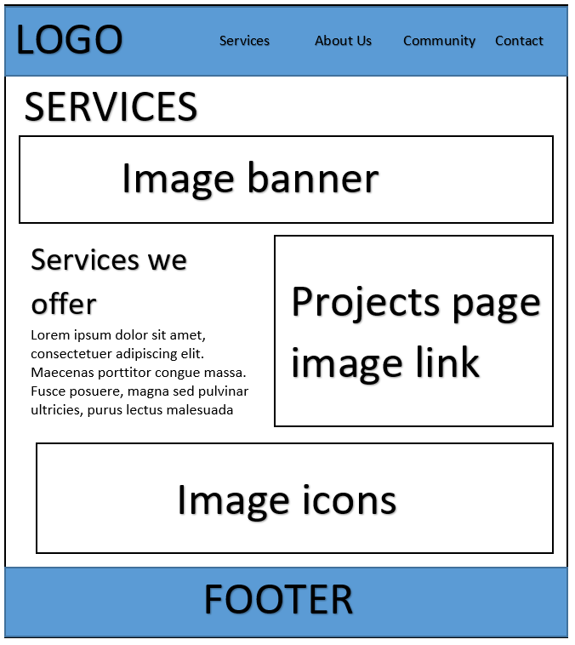

For our services page, we wanted to maintain the continuity of left-to-right viewing with a description of our web services on the left side and graphical components in the center and to the right. Our links to the site projects page will feature a series of engaging and contrasting image links to support the design philosophy of showcasing a wide variety of web designs for different types of companies.

**Services Page Print Layout**

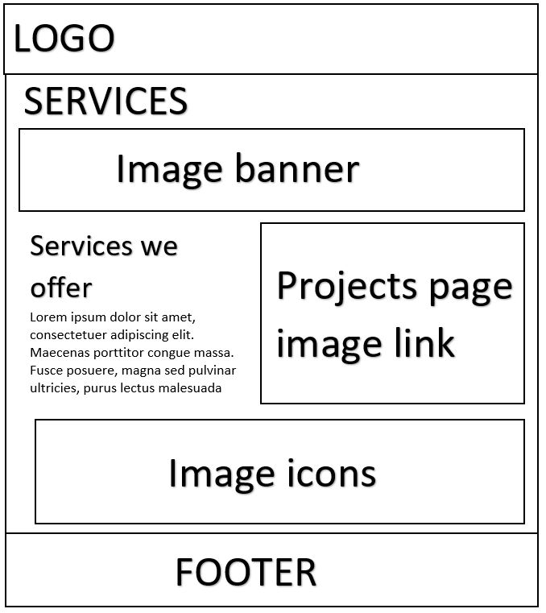

Projects Page Layout

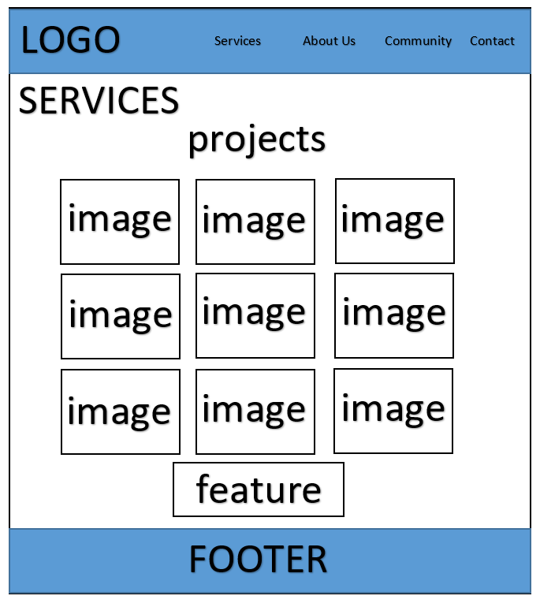

Our projects page will feature a gallery of all the previous projects our design team has worked on. This will include features that expand on each project as the user clicks on each project image. Here, the primary design layout is based on showing a wide variety of skills and projects in an aesthetically pleasing way for the user that is easy to navigate.

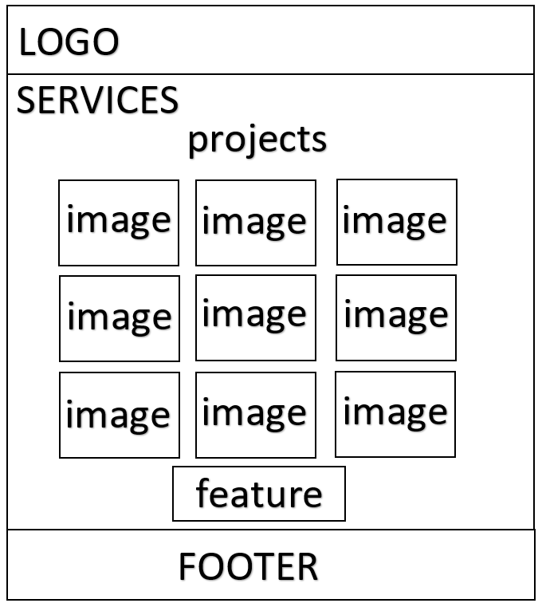Projects Page Print Layout

About Us Page Layout

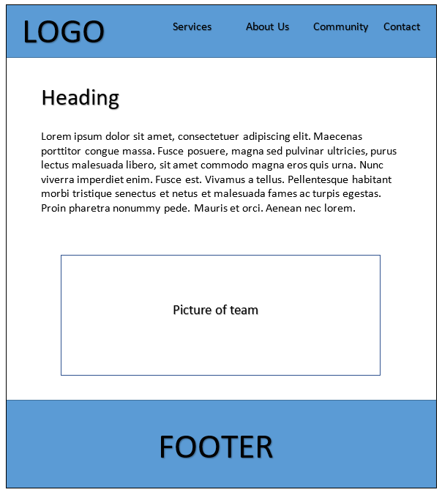

This page tells the user about who we are as a team. It will tell them about our philosophies and what makes us work well as a company. It will contain a link to the Team page which will show each team member as an individual. At the bottom, there will also be a picture of the team altogether so customers can see who we are. Text will appear at the top in order so that it is read immediately as visitors may not read the text after seeing the photo.

About Us Page Print Layout

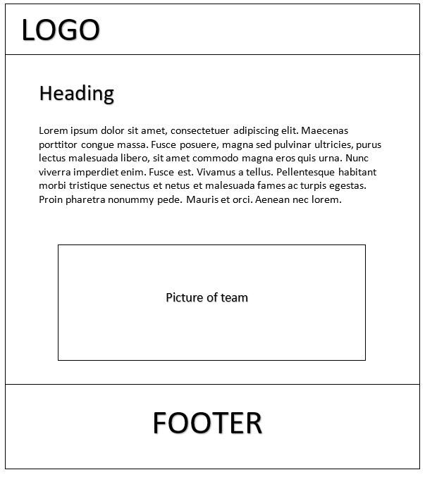

Team Page Layout

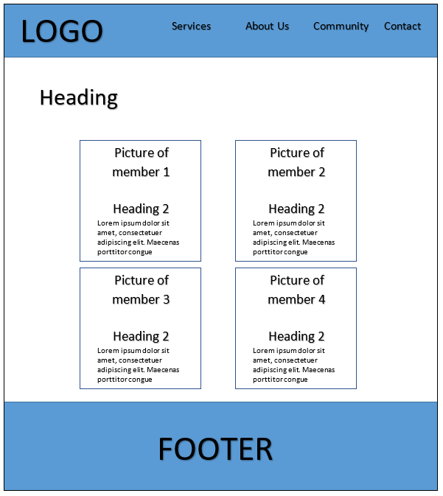

This page has a heading at the top saying “Team” and will include a div containing images of each of the members of our team in prominently in the middle of the page. Under each image there will be a text box containing their name in h2 format and a description of what they do in our standard text.

Team Page Print Layout



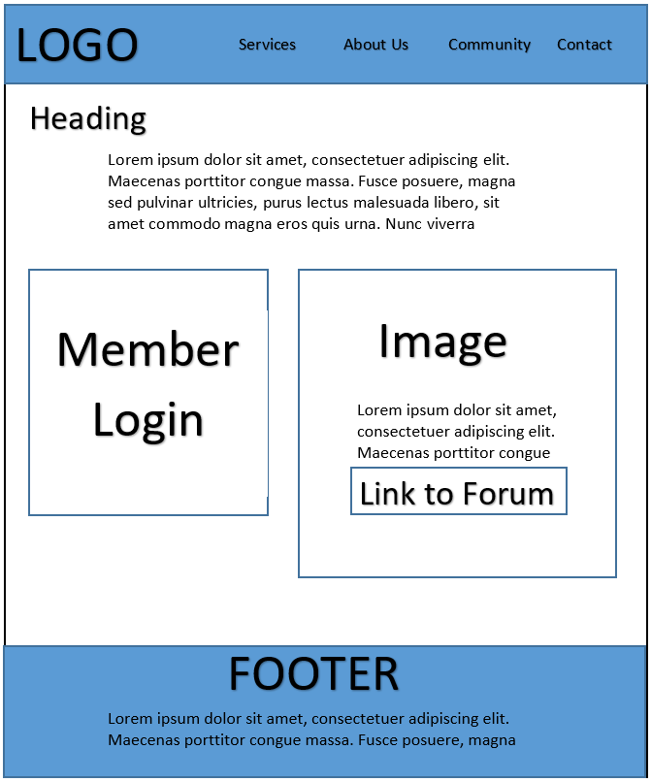Community Page Layout

The heading will contain the body of the page which describes the community services our web page offers. We will then use a separate div element for the Member Login panel and the Link to forum page. This is appropriate as we can modify each panel with individual effects and it helps keep the page looking symmetrical.

**Community Page Print Layout**

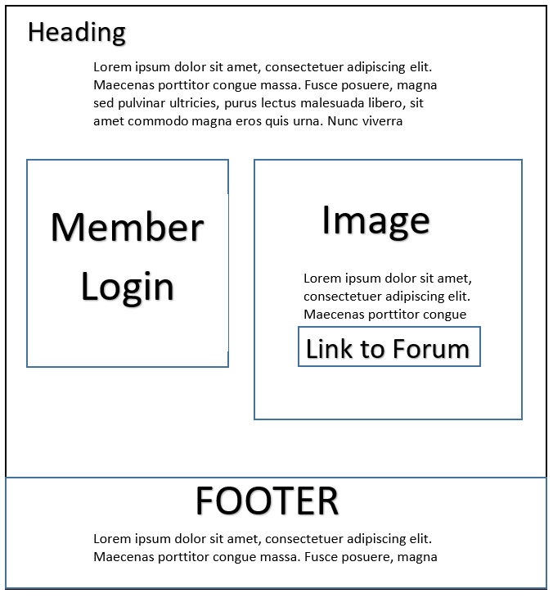

Forum Page Layout

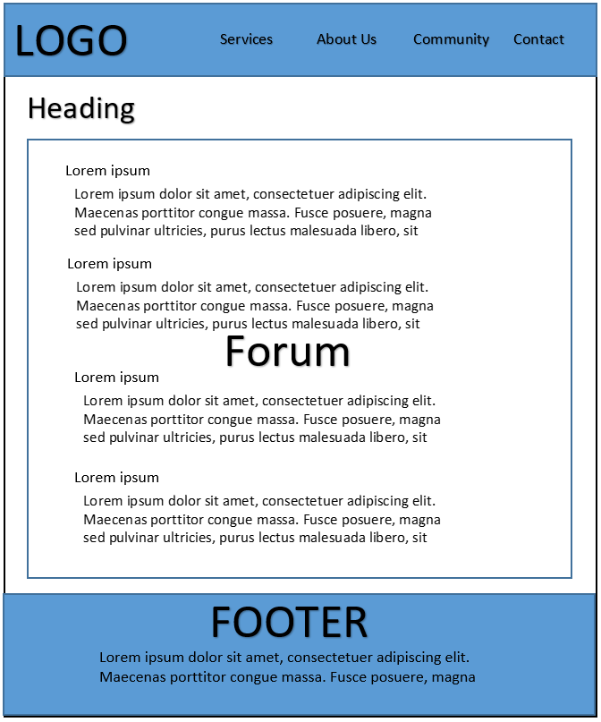

This page will contain the forum layout that is provided and community posts from members. The heading will name the page and contain a brief description of the webpage.

Forum Page Print Layout

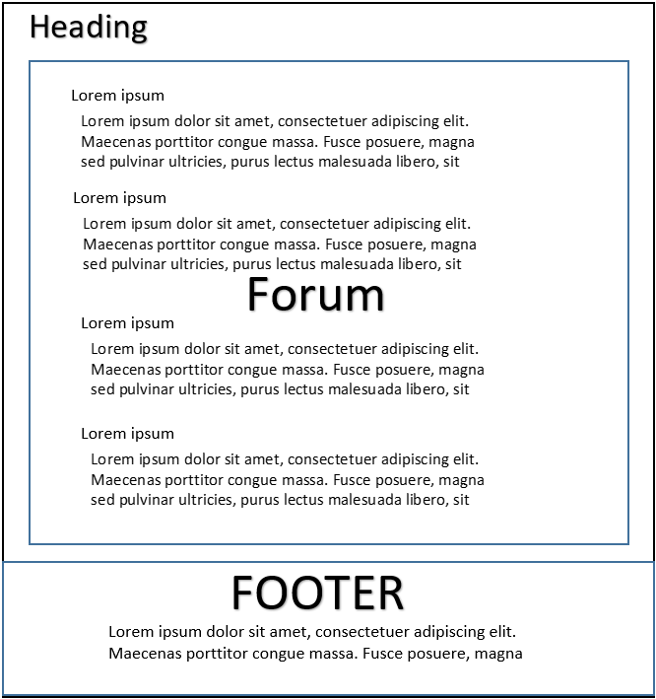

Contact Page Layout

We wanted the Contact Us page to be clean and to the point. So we kept it as simple as possible with a call to action following in the header. The Contact Us form will allow the audience to get in touch with us within a few keystrokes and a click of their mouse.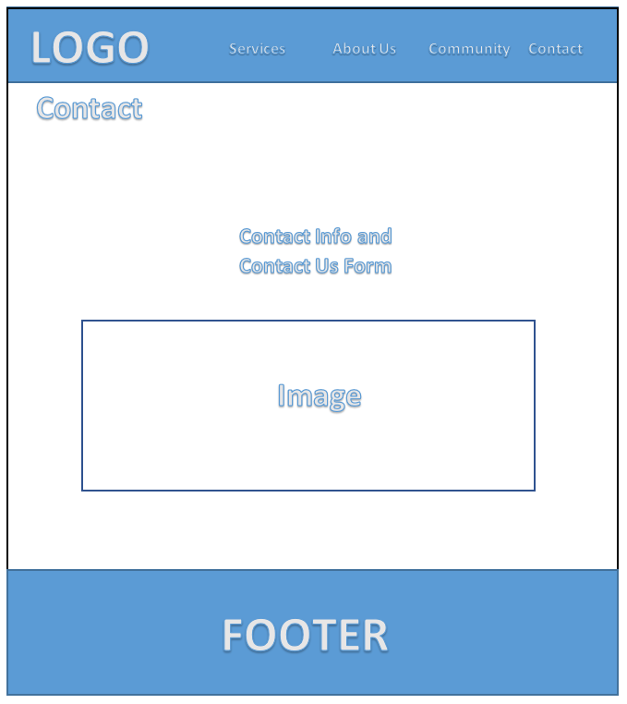

Contact Page Print Layout

# 

Forum Post Page Layout

This page show a forum post, or thread of posts if there are responses. It will also feature a response div which contains a text box for the title of the response post and a text field for the response. It also has a submit button and a cancel button.

Response Form

Message Title Text Box

Message Text Field

Post Title

Sit te vide ludus convenire, sed legere argumentum at. His oporteat laboramus ut, sit feugiat efficiendi at. Graece euripidis est ne, amet posse honestatis cum eu.

Submit

Cancel

FOOTER

LOGO

Services About Us Community Contact

Forum Post Page Print Layout

LOGO

Response Form

Message Title Text Box

Message Text Field

Post Title

Sit te vide ludus convenire, sed legere argumentum at. His oporteat laboramus ut, sit feugiat efficiendi at. Graece euripidis est ne, amet posse honestatis cum eu.

Submit

Cancel

FOOTER

New Post Page Layout

This page features a form element which consists of a text box for the title of the message or thread as well a text field for the contents of the message. It also has a submit button and a cancel button.

New Message Form

Message Title Text Box

Message Text Field

Submit

Cancel

LOGO

Services About Us Community Contact

FOOTER

New Post Page Print Layout

LOGO

Cancel

New Message Form

Message Title Text Box

Message Text Field

Submit

FOOTER

Projects Page Layout

This is the wireframe we will use to display and explain details about our projects. It will contain images of the projects as well as text to tell the visitors of the site what we did and why.

Heading

Sit te vide ludus convenire, sed legere argumentum at. His oporteat laboramus ut, sit feugiat efficiendi at. Graece euripidis est ne, amet posse honestatis cum eu.

Heading

Sit te vide ludus convenire, sed legere argumentum at. His oporteat laboramus ut, sit feugiat efficiendi at.

Project Title

Sit te vide ludus convenire, sed legere argumentum at. His oporteat laboramus ut, sit feugiat efficiendi at. Graece euripidis est ne, amet posse honestatis cum eu.

Link

FOOTER

LOGO

Services About Us Community Contact

Projects Page Print Layout

Heading

Sit te vide ludus convenire, sed legere argumentum at. His oporteat laboramus ut, sit feugiat efficiendi at. Graece euripidis est ne, amet posse honestatis cum eu.

Heading

Sit te vide ludus convenire, sed legere argumentum at. His oporteat laboramus ut, sit feugiat efficiendi at.

Project Title

Sit te vide ludus convenire, sed legere argumentum at. His oporteat laboramus ut, sit feugiat efficiendi at. Graece euripidis est ne, amet posse honestatis cum eu.

Link

FOOTER

LOGO

Services About Us Community Contact

# Appendix C: Milestone #3 Skeleton Site with Layout, Tables and Forms

**APPENDIX C:**

**MILESTONE #3**

**SKELETON SITE WITH**

**LAYOUT, TABLES AND FORMS**

URL with current completed website: http://students.bcitdev.com/A01005764/G26/index.html

COMPLETED ITEMS:

- Wireframes for planned site pages and additional necessary pages

-included sitemap page for accessibility

- Created site prototype/template which includes common features across all site pages and external style sheet

-header with functional banner and navigation bar, footer with relevant info and links, basic color scheme

- Group repository for shared work structure (Github) and assigned task roles to group members

-project manager and editor: Kevin

-graphic designer: Toni

-database administrator: Carlo

-content manager: Raly

-all of us shared the roles of web developers/designers

-Implemented basic tables as image galleries featured on home page and projects page

-Implemented basic forms on forum log-in page and contact us page

-correctly invoked PHP server-side processing on both pages

- A/B Testing for color scheme, theme, and font

-Corrected errors and edited Milestone #2 under Appendix B

-Forum Page layout with comments is correctly included and page wireframe has been created pending Milestone #4 for inclusion

-Verified HTML and CSS files were validated using the W3C validators

EXTRA WORK COMPLETED:

Our group added several features to the website in order to fit the theme of a web design company. A social media contact bar was created on the contact us page as a way for customers to reach us on multiple 3rd party online platforms. In addition, we were able to create a favicon for our site, which we feel helped support the professional feel of our site. A small back-to-top button was added to the site template to improve navigation across all site pages. We picked an appropriate logo and title for our company, and based our site color scheme on the logo.

KEY ISSUES ENCOUNTERED WITH THIS MILESTONE:

The largest issue our group encountered with this milestone was time management in order to complete everything by the set due date. Knowing that this milestone would take a lot of extra time, our group met in advance to divide up the work and begin coding the wireframes. However, it was still a challenge to complete all the pages at our current schedule with the quality we wanted our pages to be at.

In addition, troubleshooting the errors we experienced while formatting our site pages took a lot of excess time. This is the first major HTML project for all members of the team and writing the CSS document that applied the formatting that we wanted was a challenge.

The team wanted to include additional features like flexbox design and Javascript animations; however, due to time constraints we were unable to both learn and apply these features in addition to the baseline required features. After spending additional time on Javascript and PHP, for Milestone #4, we may be able to add a few of the features we wanted for Milestone #3.

DEVIATIONS FROM MILESTONE 1 AND 2:

One of the things our team deviated slightly was our color scheme. We had originally picked out a set color scheme for Milestone #2, but we wanted to keep our scheme consistent with our logo for Milestone #3. Using the color finder tool we learned about in class, we were able to make our colors consistent throughout our whole website based on an initial image.

In addition to the pages we listed in our sitemap and layouts for milestone #2, we created 4 project pages that will be used to specifically identify the unique features we can add to customers’ websites. This number of project pages was edited down to 4 from the original 9 we had planned in on our projects page. This change was made so we could actually include functional links to other websites we have actually created, which will be added as content for the next milestone.

In terms of content, we still want the goals and purpose of our site to remain the same. This content will be added in upcoming milestones and we are excited to add a multimedia image that has a video; a unique feature that we believe will differentiate our site from others.

DOCUMENTATION OF WORK:

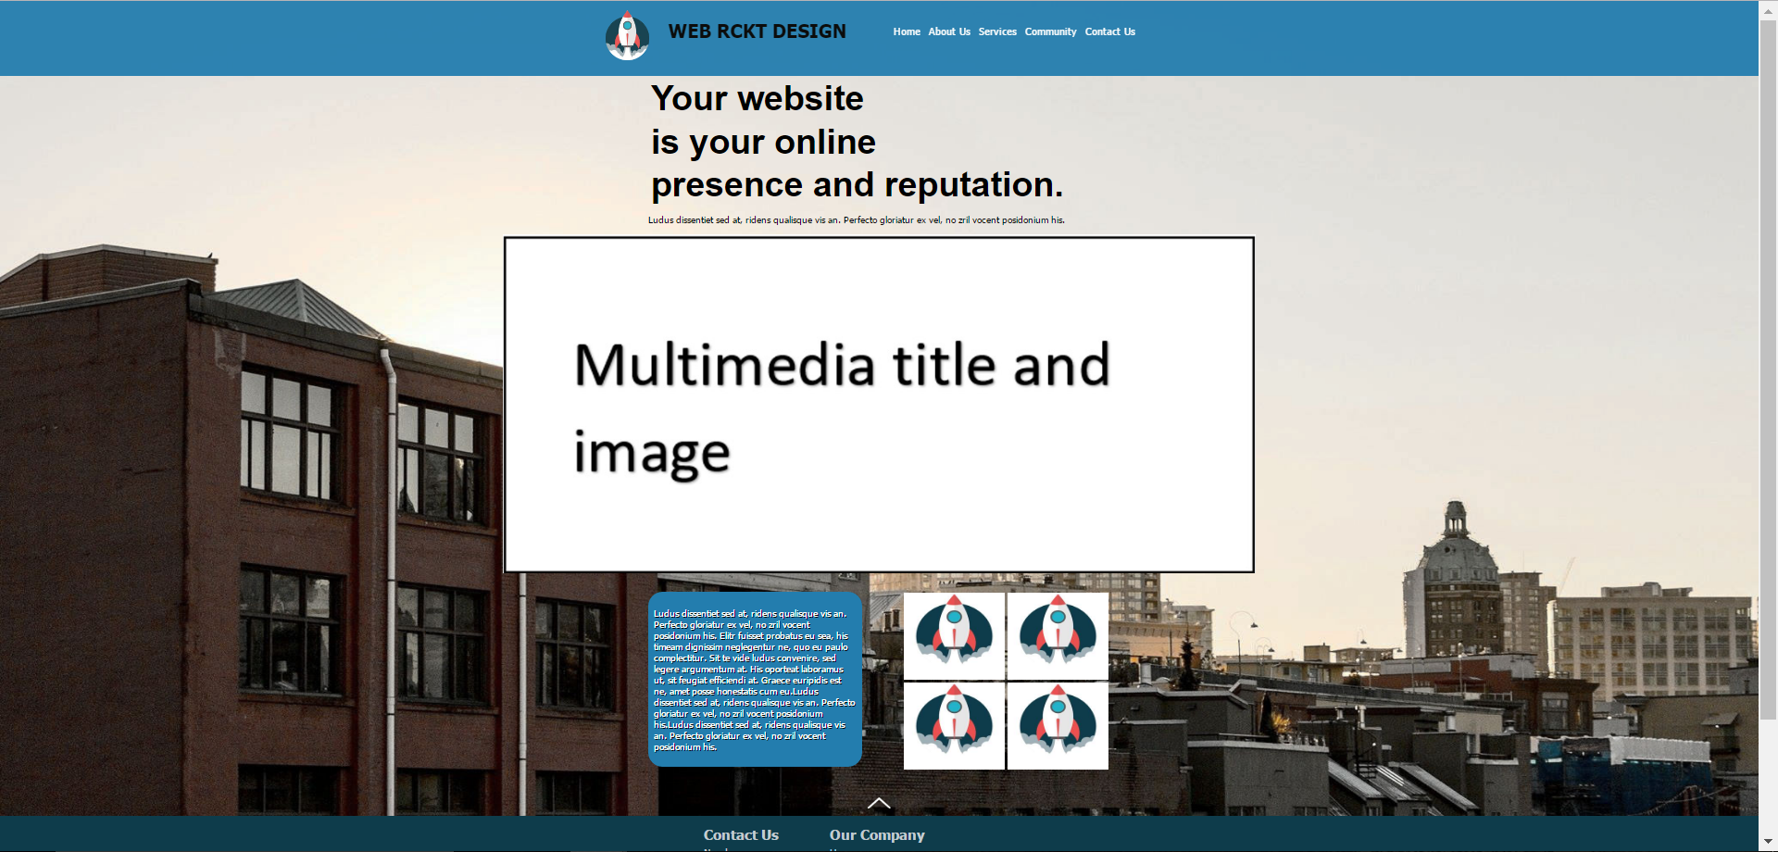FRONT PAGE

TABLE #1

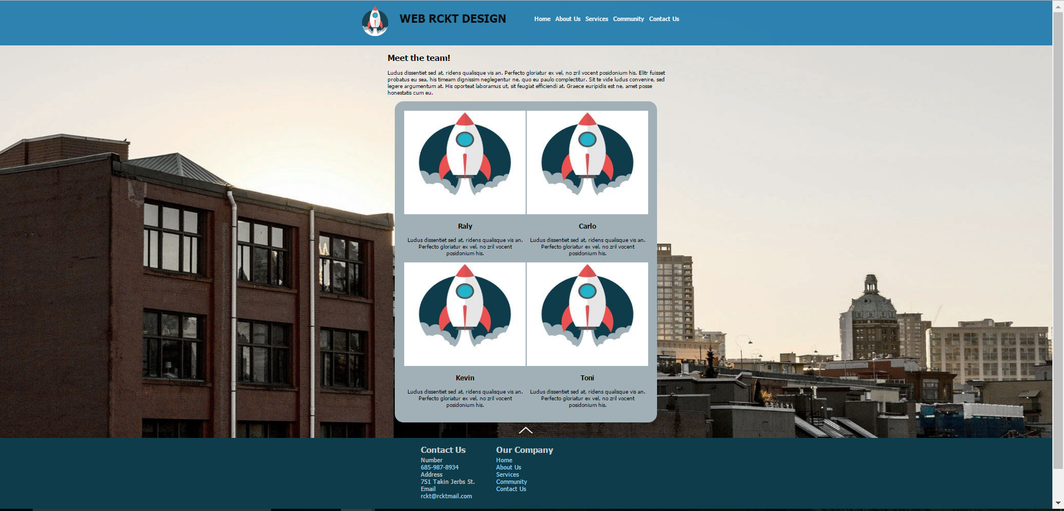

TABLE #2

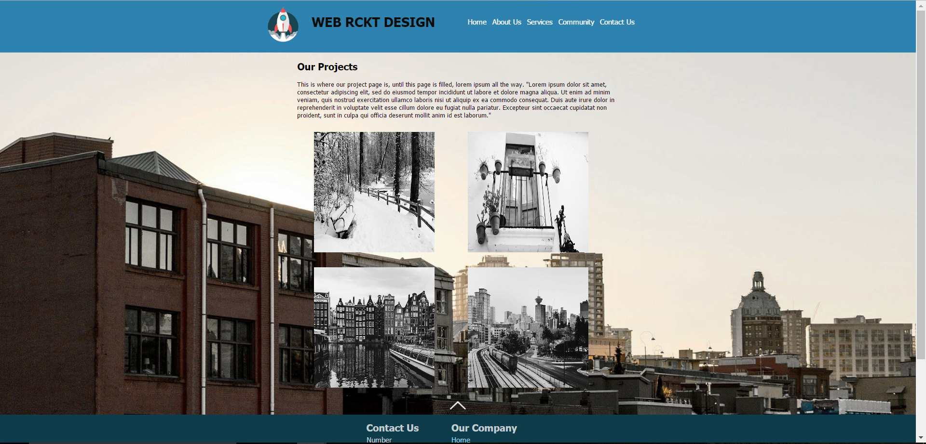

FORM #1

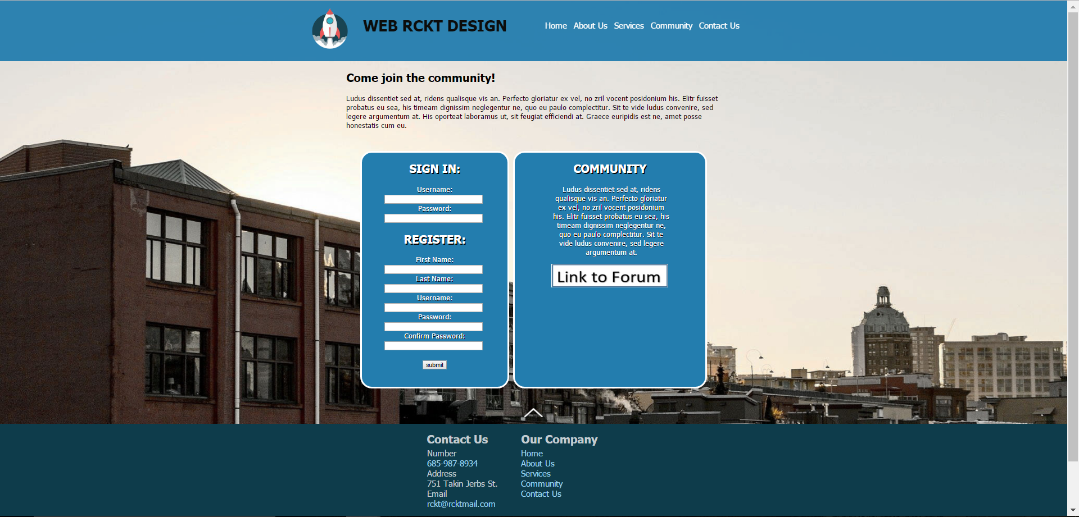

FORM #2

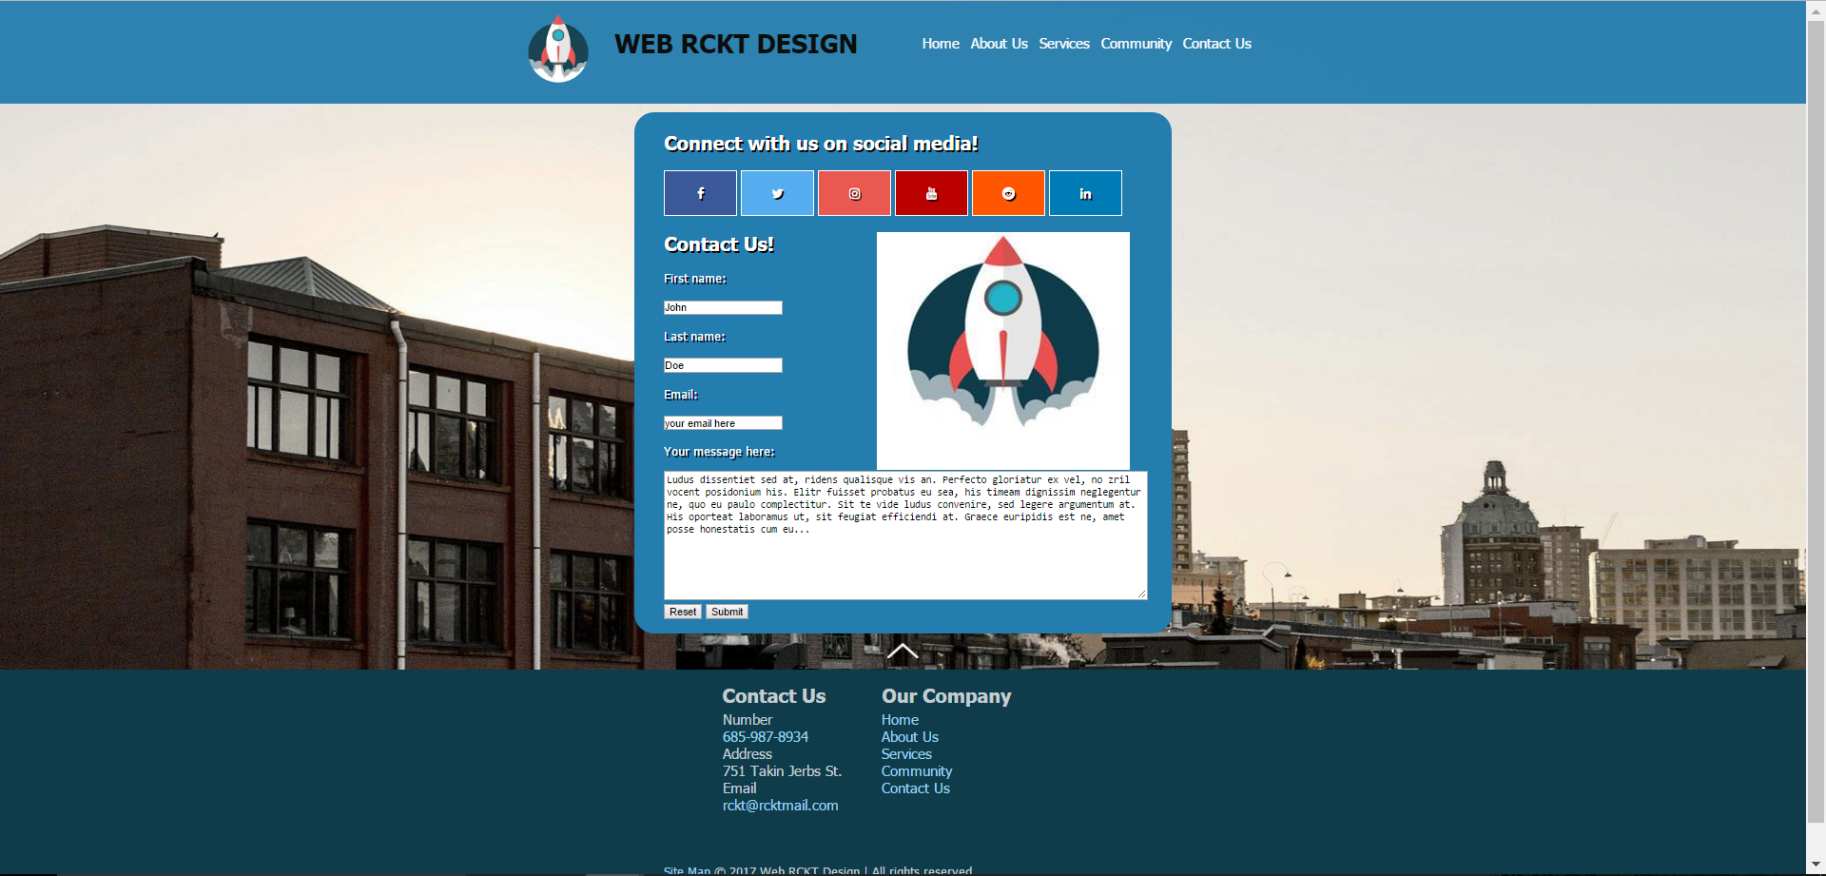

BASE CSS STYLESHEET

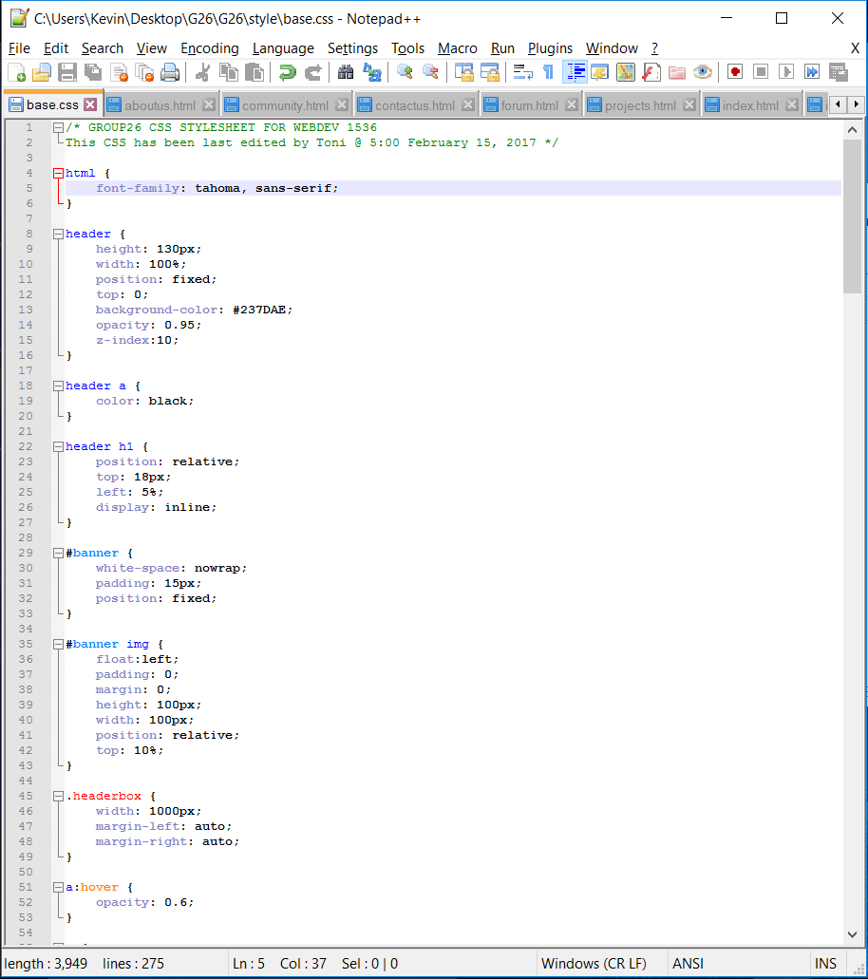

A/B TESTING

Our A/B testing portion of the milestone included a short online survey that we get our friends and family members to fill out. In this survey, we asked 3 questions: Which font style is more appealing to you? (Tahoma or Abel), Which sample color scheme is more appealing to you? (Current or Original), and Which working color scheme appeals to you most? (Current Layout Color scheme or Original Layout Color Scheme)

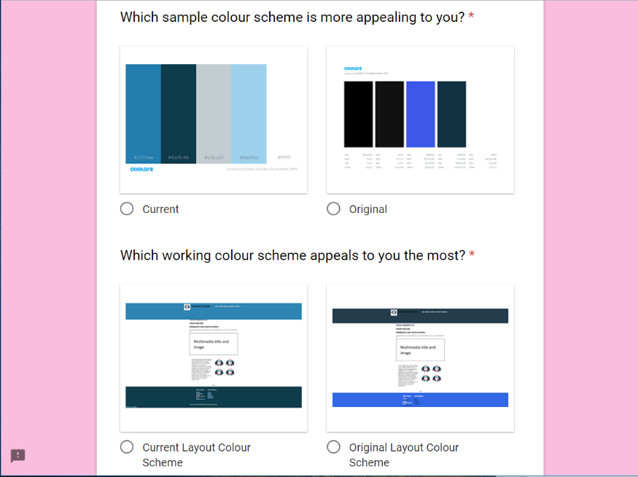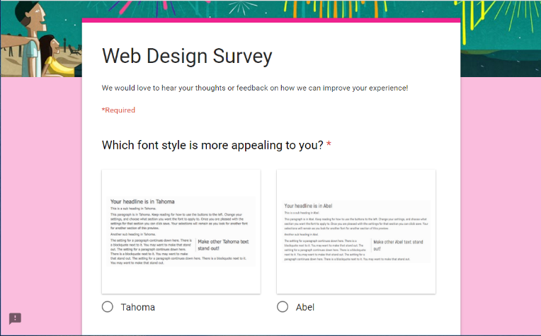Our Survey:

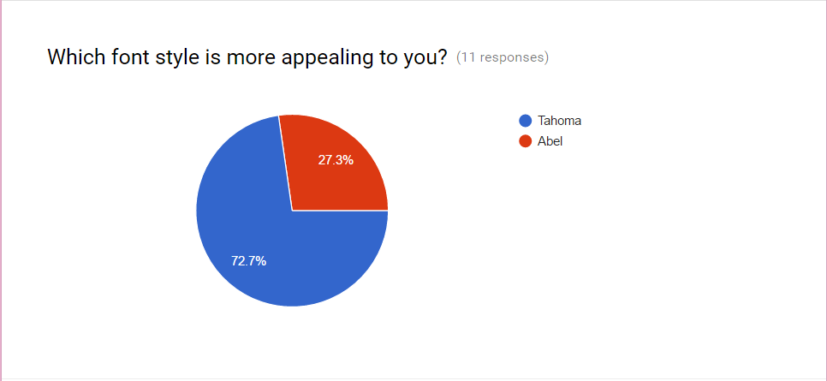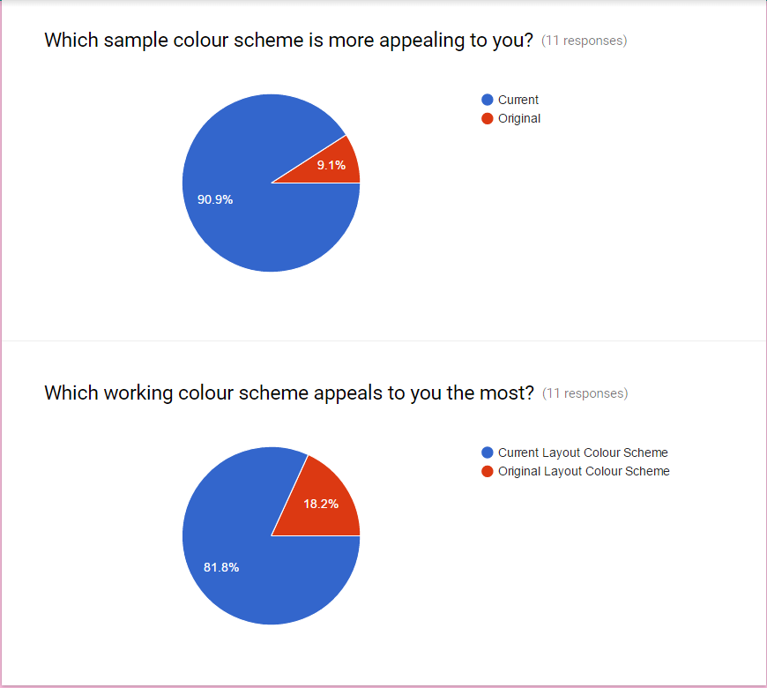The Results:

We wanted to ask two different questions based on the color scheme because we had to base our logo design around it. In addition, seeing the colors on the page would be asking more about the theme of the site, as opposed to just what set of colors looked more appealing.

We designed our site with the results of the survey in mind and are happy with the overall theme. Our site supports heavy left-side written content to support the data found in heat map research. In addition, we retained a fluid page design. Our theme in general ended up taking on more of a cartoonish look than we originally planned, but this was a design choice we made based on our finalized logo.